25th FIPS-Mouche European Fly Fishing Championship

Montenegro, 1 – 7 July 2019

RULE MODIFICATIONS

FIPS-Mouche has appointed Montenegro to be the host country for the 25th FIPS-Mouche European Fly Fishing Championship to be held in Plav – Gusinje –Andrijevica - Berane , MONTENEGRO
These Rule Modifications apply to the latest published FIPS-Mouche Competition Rules.

Article 2 : General Information
2.2. Add: Four sessions will be held in rivers, bank fishing, wading allowed. One session will be held on a lake, boat fishing, drifting boats.

Article 9: Bank Fishing Competitions
9.3. Add: The beats on the river will be an average of 150 m, without buffer zones. Depending on number of participants / water conditions a rotation may be incIuded for the river sectors.
9.4 Add: If there is an island on the beat, the controller may control from the island, to keep permanent visiual contact with the competitor. He must enter the island half an hour before the start of the session; making sure not to disturb the fishing water.
9.7 Add: Wading is allowed on the river sectors and chest waders may be worn.
Article 10: Boat fishing Competitions

10.9. Add: Fishing will be from drifting boats. Drogues are not allowed. Two competitors + controller on boat.

28.5 New: Fishing is organised as shown below

Competitor A fishes in this area of 90º
Competitor B fishes in this area of 90º
Wind and drifting direction.

No fishing behind the boat
Bow

Article 11: Duration of events, scoring and practice sessions
11.3. Add: The hours for fishing will be in the program of the championship: from 08:00 to 11:00 (11:30 if rotation on river sectors) and from 17:00 to 20:00 (20.30 if rotation on river sectors)
11.4. Add: All official practice will be catch and release, the schedule and rotation of practice beats will be in the programme of championship.
Add – All official and inofficial practice will be fished with barbless hooks.
Article 23: Care of fish caught
23.1. Add: When the competitor wants to score a fish, he has to make sure, if possible, that the fish is all the time submerged in the water, while bringing the fish to the controller. If it does not happen, that fish will be disallowed.

Article 25: Eligible fish

For all sessions: all species, minimum size 20 cm
Measuring will be done from the tip of the nose to the extremities of the tail, squeezed together.
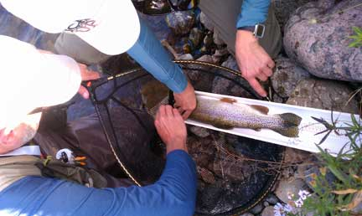
Article 29: Competition Flies
29.6. Change: Only one fly may be used ( law in Montenegro )

Article 30 Landing Nets
30.2. add : At Sec I and Sec II, the total extended length of the net may be a maximum of 2,5m. This is due to the possibility of high banks in Sec II
Annex A Rotation Matrix.
- Sector I LUCA River - GUSINJE River fishing
- Sector II Lake Plav Lake fishing from drifting boats
- Sector III LIM River - PLAV River fishing
- Sector IV LIM River - ANDRIJEVICA River fishing
- Sector V LIM River - BERANE River fishing

Rotation Matrix between Sectors
GROUPS | Wednesday 3/7 AM | Wednesday 3/7 PM | Thursday 4/7 AM | Friday 5/7 AM | Friday 5/7 PM
A | I | II | III | IV | V
B | II | III | IV | V | I
C | III | IV | V | I | II
D | IV | V | I | II | III
E | V | I | II | III | IV

