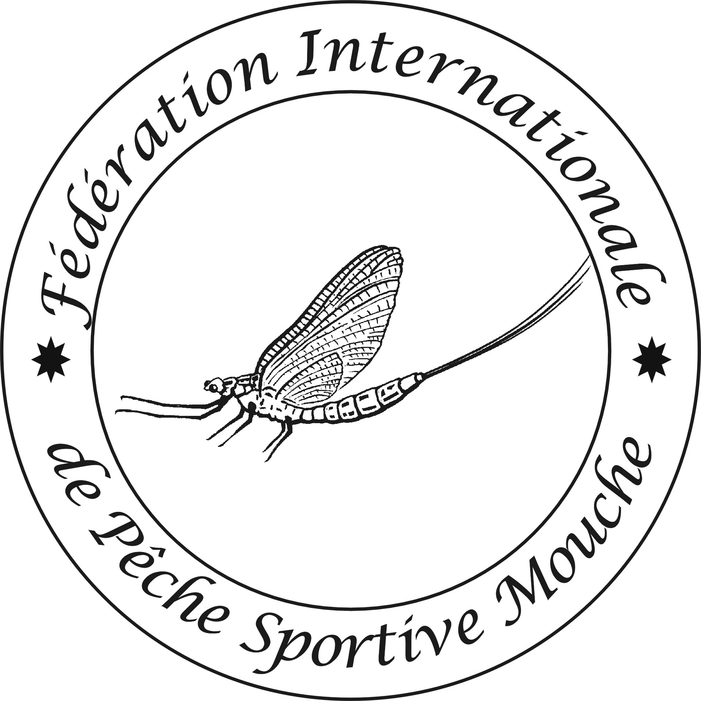

5th FIPS-Mouche Masters Fly Fishing Championship
Dullstroom, Mpumalanga, South Africa 10-16/02/2019

RULE MODIFICATIONS
FIPS-Mouche has appointed South Africa to be the host country for the 5th FIPS-Mouche Masters Fly Fishing Championship to be held in Dullstroom, South Africa
These Rule Modifications apply to the latest published FIPS-Mouche Competition Rules.

Article 2 : General Information
2.2. Add: Three sessions will be held on stillwaters, boat fishing. One session will be held in river, bank fishing, wading allowed.

Article 9: Bank Fishing Competitions
9.3. Change: The beats will be an average of 120 m with buffer zones where possible.
9.8 : Wading is allowed on the sectors and chest waders may be worn, wet wading will do !
Article 10: Boat fishing competitions
10.4 Change: Boats will be launched 15 minutes before the start of the session.
10.9 add: Drogues are allowed, motors will electric, life jackets are compulsory and must be provided by the competitors.

Article 11: Duration of events, scoring and practice sessions
11.3. Add: The hours for fishing will be in the program of the championship: from 07:30 to 10:30 and from 15:00 to 18:00
11.4. Add: All official practice will be catch and release, the schedule and rotation of practice beats will discussed during the Captains‘ Meeting.

Article 12: Who may participate
12.1. Add: A maximum number of 12 teams can be accepted. Second teams may be accepted provided that the team is completely composed of Masters Women.

Article 15: Team Captains
15.3 Change: In sector III and IV (Nooitgedacht Dam and Rivendell River) access to the sector is only possible at the start of the sessions due to private entrance gate access. Captains wishing to have access to their members on the river sector will have to enter with the team.

Article 25: Eligible fish
25.1. Add: Eligible fish species:
Brown Trout (Salmo Trutta Fario), Rainbow Trout (Oncorhynchus mykiss) and Spekboom Red (local Rainbow variant)
All fish with a minimum length of 200 mm.
Measuring will be done from the tip of the nose to the extremities of the tail, squeezed together.

Article 30: Landing nets
30.2. Change: Only for boat fishing on Sector II (The Lochs): Fully extended, a landing net may not exceed 250 cm

Annex A Rotation Matrix.
- Sector I Dullstroom Town Dam Boat fishing
- Sector II The Lochs Dam Boat fishing
- Sector III Nooitgedacht Dam Boat Fishing
- Sector IV Rivendell River Bank fishing

Rotation Matrix between Sectors

GROUPS | Tuesday 12/02 AM | Tuesday 12/02PM | Thursday 14/02 AM | Thursday 14/02 PM
A | I | II | III | IV
B | II | I | IV | III
C | III | IV | I | II
D | IV | III | II | I

Annex A Boat fishing

